**TEST PLAN 1**

* runs[]={50,100,50},wkts[] = {3,4,5},maidens[]={1,0,2};
* inngs = 3,no = 0;
* overs[]={4,4,4};

|  |  |  |
| --- | --- | --- |
| FUNCTION NAME | INPUT | OUTPUT |
| best_score(inngs,runs) | (3,[50,100,50]) | 100 |
| total_runs(runs,inngs) | ([50,100,50],3) | 200 |
| no_of_fifty(runs,inngs) | ([50,100,50],3) | 2 |
| no_of_century(runs,inngs) | ([50,100,50],3) | 1 |
| no_of_overs(inngs,overs) | (3,[4,4,4]) | 12 |
| total_wickets(inngs,wkts) | (3,[3,4,5]) | 12 |
| bowler_avg(runs,inngs,wkts) | ([50,100,50],3,[3,4,5]) | 16.67 |
| bowler_economy(runs,inngs,overs) | ([50,100,50],3,[4,4,4]) | 16.67 |
| no_of_3wkts(inngs,wkts) | (3,[3,4,5]) | 2 |
| no_of_5wkts(inngs,wkts) | (3,[3,4,5]) | 1 |
| best_wkts(inngs,wkts) | (3,[3,4,5]) | 5 |
| no_of_maidens(inngs,maidens) | (3,[1,0,2]) | 3 |

**Input**

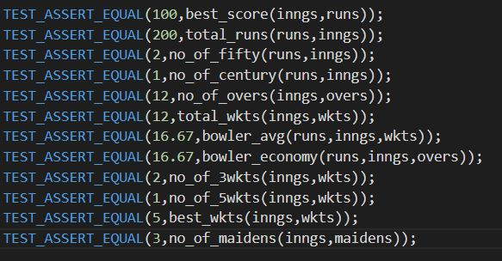

**Output**

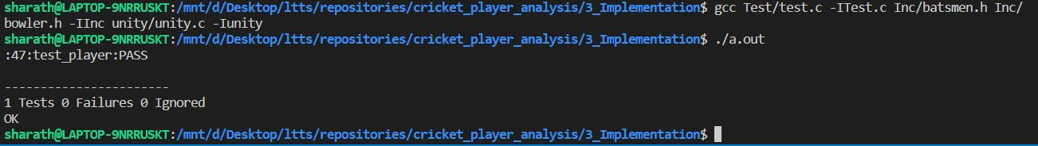

**TEST PLAN 2**

* runs[]={50,106,12},wkts[] = {4,1,6},maidens[]={0,0,4};
* inngs = 3,no = 0;
* overs[]={7,10,8};

|  |  |  |
| --- | --- | --- |
| FUNCTION NAME | INPUT | OUTPUT |
| best_score(inngs,runs) | (3,[50,106,12]) | 106 |
| total_runs(runs,inngs) | ([50,106,12],3) | 168 |
| no_of_fifty(runs,inngs) | ([50,106,12],3) | 1 |
| no_of_century(runs,inngs) | ([50,106,12],3) | 1 |
| no_of_overs(inngs,overs) | (3,[7,10,8]) | 25 |
| total_wickets(inngs,wkts) | (3,[4,1,6]) | 11 |
| bowler_avg(runs,inngs,wkts) | ([50,106,12],3,[4,1,6]) | 15.27 |
| bowler_economy(runs,inngs,overs) | ([50,106,12],3,[7,10,8]) | 6.72 |
| no_of_3wkts(inngs,wkts) | (3,[4,1,6]) | 1 |
| no_of_5wkts(inngs,wkts) | (3,[4,1,6]) | 1 |
| best_wkts(inngs,wkts) | (3,[4,1,6]) | 6 |
| no_of_maidens(inngs,maidens) | (3,[0,0,4]) | 4 |

**INPUT**

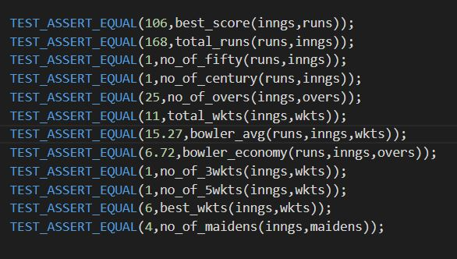

**OUTPUT**

